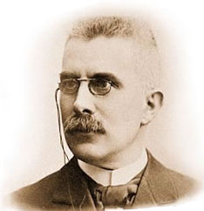**Le Ch­­­­­­­­­­­­­­­­­­­­­­­­­­­­­­­­­­­­­­­­­­­­­­­­­­âtelier’s Principle**

A useful generalisation that states:

*“If an equilibrium system is subjected to a change the system will adjust itself to partially oppose the effect of the change”*

*Important points:*

* When a change is applied to an equilibrium system that results in it no longer being in equilibrium, a net reaction occurs that counteracts the effect of the change.
* There will be an increase in the amount of reactant or products depending on the change
* Eventually equilibrium will be reached at a new equilibrium position.

